Logo

Color scheme
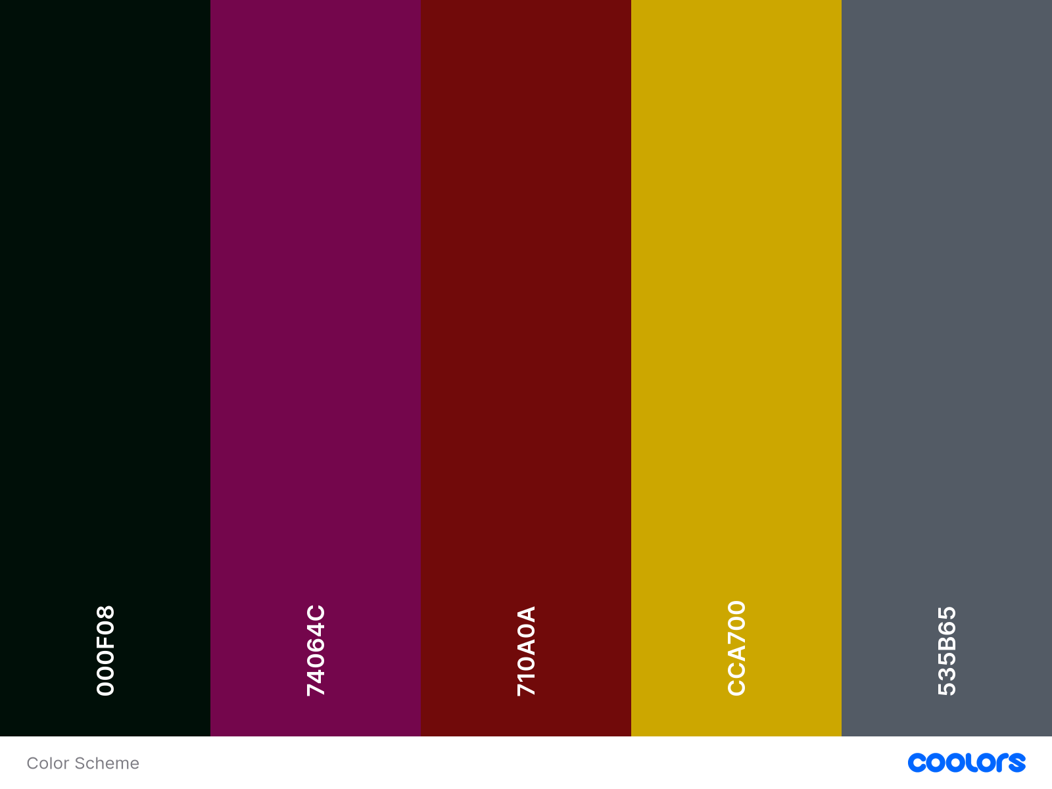

Fonts
(Courier New, monospace), (Courier, monospace), (American Typewriter, serif), (Luminari, fantasy), (Brush Script MT, Brush Script Std, cursive)
Wireframe

